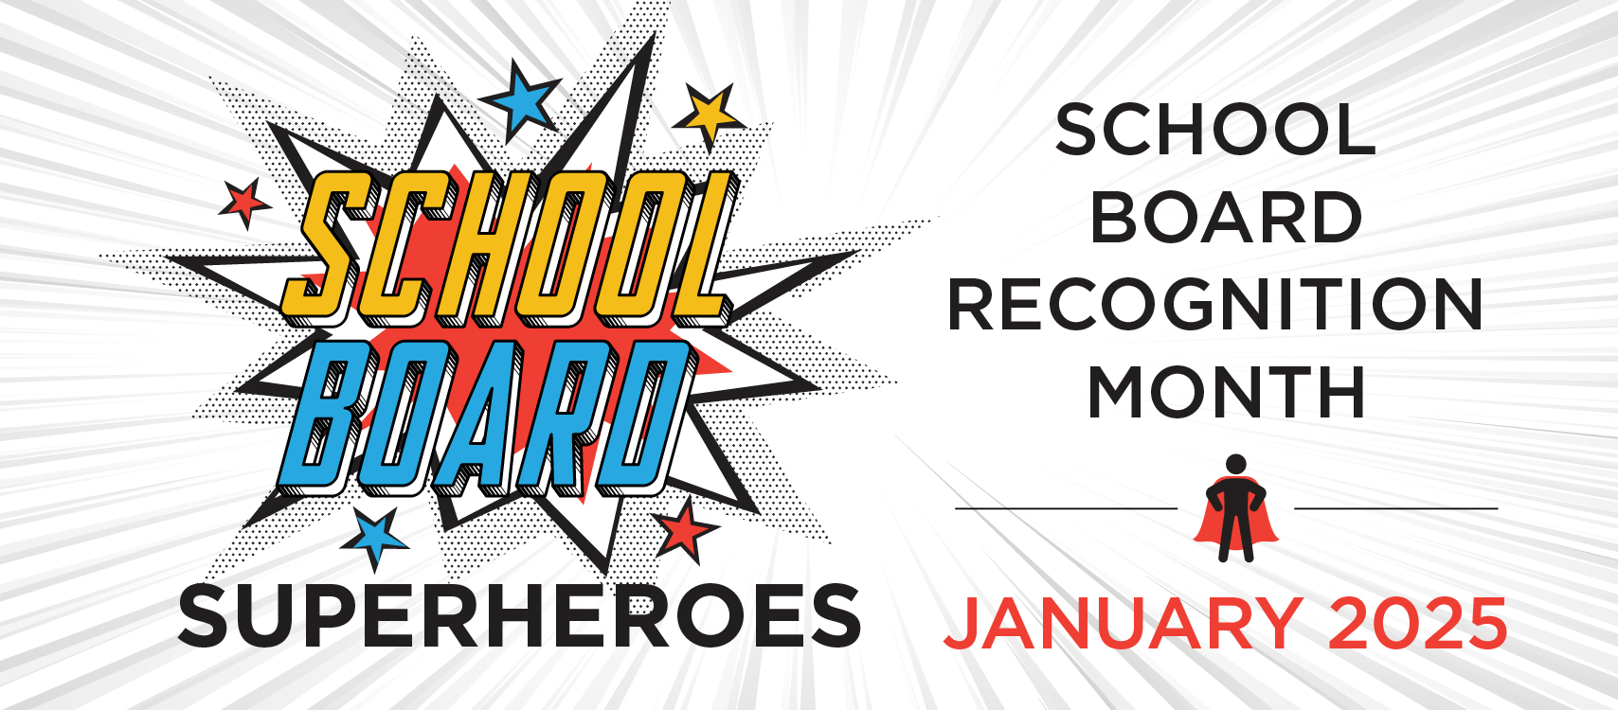

This Super Hero is beginning his 4th year on the TCS Board. Larry is a career educator. He worked for Carey Exempted Village Schools as a mathematics teacher and coach for 10 years. For the past 40 years, he has been actively involved in Tiffin City Schools as a teacher, guidance counselor, high school principal, interim high school athletic director, interim Middle School Dean of Students and interim high school principal.

His goals on the Board are:

* To always work to do what is Best for Kids.
* To add stability to the Board of Education.
* To work to advance the district academically. We must work to keep expectations high for our educators and our students to assure that when they graduate from Columbian High School that they are college or career ready and become contributing adult members of society.
* To make sure that the district is financially stable and to work on

facilities upgrades.

Larry Kisabeth



We appreciate **our**

Board of Education

and

all they do for **our**

District.

**Tiffin City Schools**

**TIFFIN CITY SCHOOLS**